
You are invited to the
21ST Church of God of Prophecy, Inc.
1920 West 21st Street
Jacksonville, FL 32209



SUPPLIES AND NEW AND SLIGHTLY USED CLOTHES
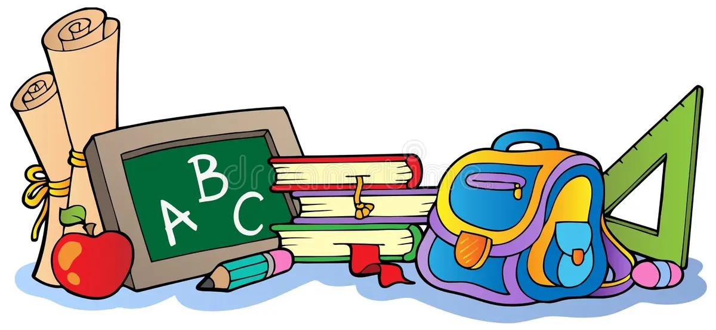
Date: August 8, 2026 Time: 11:00 am to 1:00 pm

FREE LUNCH 12 PM

The Raymond E. Davis Park

Pastor John Willis Asst. Pastor William Herron

